**What is Torticollis and Plagiocephaly??**

**Torticollis:**

Torticollis is the term for a condition when the muscles in the neck are tight and asymmetrical, otherwise known as “wry neck”. A baby may be born with this, otherwise known as “congenital torticollis” which is likely due to the baby’s position in utero or they can develop this condition early in life. The muscle tightness affects the Sterno-Cleido-Mastoid muscle, also known as the SCM muscle and will usually cause the child to rotate their head to one direction and tilt their head to the opposite direction

.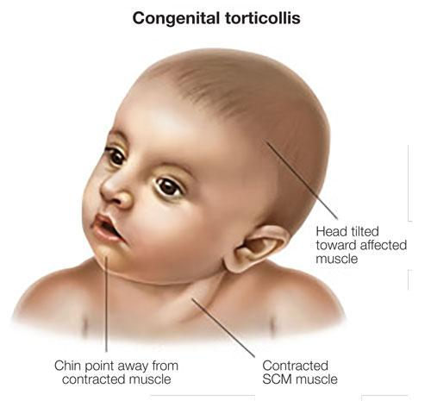

**What to look for:**

-Most parents or doctors first notice a head turn preference to one side and a difficulty to maintain the head position in midline or to hold a sustained position to the opposite side.

-Many times there is a difficulty feeding to one side over another

-Some notice tightness in the muscles of the neck, even an area of redness on one side of the neck more than the other side

**What is Plagiocephaly?**

Plagiocephaly is also known as an asymmetric head shape, or a flattening of one side of the skull, which happens when a child places more pressure on one side of the skull more than the other. It is often related to Torticollis as a child often has a flattening of the skull on the side that the head is rotated toward. Some children have a more symmetrical flattening pattern of the back of the skull , called Brachiocephaly. If this is noticed in your child it is important to contact your pediatrician and Physical Therapist to evaluate your child if further treatment is indicated.

**Now what?**

**What should I do to prevent or treat Torticollis?**

**1. Tummy Time!!!**

***“Back to Sleep and Tummy to Play!”***

* Supervised Tummy time is important to strengthen the neck, chest, core and upper body muscles
* Start with short but frequent sessions throughout the day, as soon as baby comes home from hospital, and increase gradually as your baby becomes more comfortable.

**2. Change Positions Frequently**

* Don't forget to place baby on their sides, back and tummy and alternate positions throughout the day
* Sidelying position promotes reaching and bringing hands to midline

**3. Limit time spent in a “Container”**

Be mindful of how much time your baby spends in a contained space such as a carseat, stroller, swing, bouncy seat as this will limit their freedom of movement and will often result in a head position tilted to one side more than the other, and may result in muscle tightness.

**4. Alternate Positions for the baby**

* Pay attention to the position that you hold or carry your baby and make sure to switch positions to promote active rotation to both directions
* change positions of which end you place the baby in the crib, to promote looking to both directions and visually exploring their environment
* make sure that you change the position and direction you are holding the baby during feedings